NCI/CBIIT

GreenSheets System
Use-Case Specification: View and Manage a greensheet

Version 1.12

Prepared for:
The National Institutes of Health
National Cancer Institute
CBIIT

Document Location
Ensure that this document is current. Printed documents and locally copied files may become obsolete due to changes to the master document. The source of this document is located in the Subversion SVN documentation repository at: https://ncisvn.nci.nih.gov/svn/iscs/greensheets/Requirements/Use-cases/View%20and%20Manage%20a%20greensheet%20use-case_NEW.doc

Revision History
Version Number | Revision Date | Author | Summary of Changes
1.0 | 4/10/2017 | G. Tulchinskaya | Created this version after OGA approval of the mockups
1.1 | 5/18/2017 | G. Tulchinskaya | Changed Program Analyst to Program Staff role throughout the document
1.2 | 6/01/2017 | G. Tulchinskaya | Modified after the meeting with OGA sec.  BUSINESS RULES and Corresponding Errors => Display rules => Expand/Collapse questions
1.3 | 6/09/2017 | G. Tulchinskaya | Updated mockups and icons
1.4 | 6/15/2017 | G. Tulchinskaya | Modified after the meeting with OGA sec.  BUSINESS RULES and Corresponding Errors => Display rules => Expand/Collapse questions
1.5 | 6/26/2017 | G. Tulchinskaya | Modified the text of the warning after OGA approval  OGA requested to rename ‘Action’ column in the “Previously Saved Attachment(s)” section  Modified Reset GS functionality (after req review and OGA approval)
1.6 | 7/12/2017 | G. Tulchinskaya | Modified Display rules (after prod issue)
1.7 | 8/01/2017 | G. Tulchinskaya | Added sec. “Tool Tips”
1.8 | 8/17/2017 | G. Tulchinskaya | Modified:  Sec. Additional requirements => Tool Tips  Sec. Business Rules => Display rules => Read-only greensheets when GPMATS action is in Closed status
1.9 | 9/05/2017 | G. Tulchinskaya | Changed a tool tip text for ‘I’ icon
1.10 | 9/07/2017 | G. Tulchinskaya | Added sec. Additional requirements => Greensheet is NOT available
1.11 | 10/11/2017 | G. Tulchinskaya | Modified sec. Business Rules => Validations rules (attachment title name)  Added sec. UI Mockups => Attachment(s) pop up
1.12 | 11/03/2017 | G. Tulchinskaya | After the OGA decision NOT to implement the bag of attachments => modified sec. Manage attachment(s) for a selected question

Reference Documents
Document Name | SVN Location
GreenSheets Re-design Project Scope | https://ncisvn.nci.nih.gov/svn/iscs/greensheets/Requirements/Specs/GreenSheets%20Redesign%20Project%20Scope.docx
Print a greensheet use-case | https://ncisvn.nci.nih.gov/svn/iscs/greensheets/Requirements/Use-cases/Print%20a%20greensheet%20use-case.doc
Form Builder – scope of changes.docx | https://ncisvn.nci.nih.gov/svn/iscs/greensheets/Requirements/Specs/Form%20Builder%20-%20Scope%20of%20changes.docx
Search and View Greensheets use-case | https://ncisvn.nci.nih.gov/svn/iscs/greensheets/Requirements/Use-cases/Search%20and%20View%20greensheets.doc

Key terms
Refer to GreenSheets Re-design Project Scope

Table of Contents

1. SUMMARY 6
1.1 Brief Description 6
1.2 Actor(s) 6
1.3 Goal(s) 6
2. USE-CASE DIAGRAMS 7
3. PRE-CONDITION(S) 7
3.1 Navigate 7
4. FLOWS OF EVENTS 8
4.1 Basic flow: View a greensheet 8
4.2 Alternative flows 9
4.2.1 Close or Navigate away from a greensheet screen 9
4.2.2 Edit and Save a greensheet 10
4.2.3 Reset a greensheet 10
4.2.4 Submit a greensheet 11
4.2.5 Manage attachment(s) for a selected question 11
4.3 Exception Flows 13
5. POST-CONDITIONS 13
5.1 Post-conditions upon Success 13
5.1.1 Greensheet is displayed 13
5.1.2 Greensheet is Edited and Saved 13
5.1.3 Greensheet is reset 13
5.1.4 Greensheet is submitted 13
5.2 Post-Conditions upon Failure 13
5.2.1 System error is displayed for unhandled errors 13
5.2.2 Error message(s) are displayed for handled validation errors 13
6. EXTENSION POINTS 14
6.1 Create PDF 14
7. BUSINESS RULES and Corresponding Errors 14
7.1 Display rules 14
7.2 Validation rules 18
8. Information messages table 19
9. USER INTERFACE 19
9.1 UI Mockups 19
9.1.1 Greensheet questionnaire mockup 19
9.1.2 Greenseet after a new template has been promoted 20
9.1.3 Greenseet Submitted or Frozen 20
9.1.4 Attachment(s) pop up 21
9.2 UI Specifications 21
9.2.1 Grant Header 21
9.2.2 Links and Buttons 23
9.2.3 Questionnaire 24
10. REPORTING REQUIREMENTS 25
11. Additional requirements 25
11.1 Tool tips 25
11.2 Greensheet is NOT available 26

SUMMARY

Brief Description
This use-case describes functionality allowing Actor to view and/or manage a questionnaire (known as a greensheet) for a specific grant

Actor(s)
- Program Director (PD)
- Program Staff (PS)
- Diversity supplement PD. NOTE: only one user (minoritysupplements.userids=OGUNBIYIP)
NOTE: This exists as a different privilege and is provided to both PD and Program Analyst roles. This user can see only minority supplements grants that met the generic conditions. From the code:
incrementalQuery += GrantDAOImpl.BLANK_SPACE + "AND MB_MINORITY_FLAG = :mbMinorityFlag";
sqlParms.addValue("mbMinorityFlag", "Y");
- Grants Management Specialist (Specialist)
- I2E User
For details please refer to GreenSheets Re-design Project Scope, Sec. GreenSheets users => User Roles

Goal(s)
- View greensheet(s)
- Edit and Save a greensheet
- Reset a greensheet
- Submit a greensheet
- Manage attachment(s) for a selected question

USE-CASE DIAGRAMS
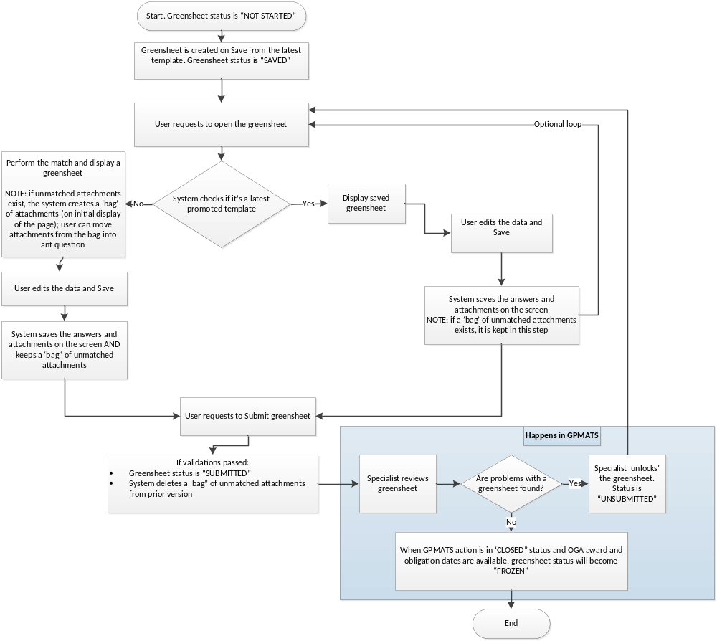 Notes:
- When user saves the “reconciled” GS (opened with the new template version), system deletes all answers associated with the “previous” template
- If user selects and use the attachment from the “bag” of unmatched attachments, selected attachments should be removed from the “bag” on save.

PRE-CONDITION(S)

Navigate
Actor navigated to a greensheet in one of the following ways:
Actor | From the system
PD/PS/ Diversity supplement PD | - Notifications => see GreenSheets Re-design Project Scope, sec. Other system relationships => Notifications  - YourGrants => see GreenSheets Re-design Project Scope, sec. Other system relationships => YourGrants; NOTE: YourGrants doesn’t display ‘G” icon if AWARD action is in Cancelled status in GPMATS  - GreenSheets => from the Search/hit list screen.
Grants Management Specialist (Specialist) | - eGrants => see GreenSheets Re-design Project Scope, sec. Other system relationships => eGrants - changes for re-design  - GreenSheets => from the Search/hit list screen  - GPMATS => see JIRA ticket GREENSHEET-524, GPMATS-760 and requirements in GreenSheets Re-design Project Scope, sec. Dependencies with other systems => Significant dependencies => GPMATS - changes for re-design
I2E User | - GreenSheets => from the Search/hit list screen

FLOWS OF EVENTS

Basic flow: View a greensheet
- The system determines if the template for this grant type/grant mechanism /greensheet type has been promoted from Form Builder.
  - If template is NOT found, the system displays an error message:
For AWARD action:
“Greensheet Questionnaire Not Found
Greensheet Questionnaire definition was not found for type <insert type/mech> grants.
Please contact support if you feel that greensheet questionnaires for such grants should be defined.”

For Revision action:
“Greensheet Questionnaire Not Found
Greensheet Questionnaire definition was not found for Revision action.
Please contact support if you feel that greensheet questionnaires for such grants should be defined.”
Use-case ends.

  - If template IS found, the system determines which questionnaire to display based on the logic below.
Greensheet Status | System behavior when user retrieves greensheet
Greensheet is in status “Not Started” | Latest version of template (latest questions) is displayed;  NOTE: For the rules who can edit a greensheet in “Not Started” status, see GreenSheets Re-design Project Scope  - Sec. Diagrams => User (real person) functionality  - Sec. GreenSheets users => User roles
Greensheet is in status “Submitted” and/or “Frozen” | Version of template on the moment of submission is displayed. All answers and comments are displayed in read-only mode; there is no ability to add/delete attachments.  Greensheet in status “Submitted” or “Frozen” is displayed as read-only.
Greensheet is in status “Saved” (not yet submitted) | The system checks if a new template has been promoted from Form Builder since the last save.  - If a new template HAS been promoted, then:  - Latest version of template (latest questions) is displayed.  - System will automatically match the answers/comments/attachments for the questions that did not change. (Note: partial reconciliation is NOT needed, meaning that if question did not change, but answer options are changed, we will consider it as a changed question and will NOT copy attachments and comments).  - System will display a warning message that the template has changed and instructions to a user. See the text in sec. Information messages table => I-001  - If a new template has NOT been promoted since the last save, then the system displays saved greensheet (questions/answers/comments/attachments).  NOTE (applicable to both scenarios): After the match is performed in the first scenario, the system creates ‘a bag’ of unmatched attachments from a prior version. The system will provide ability to move attachment(s) from a ‘bag’ into a question. See this document, alternative flow “Manage Attachment(s)”  This ‘bag’ is kept until greensheet is submitted. The user will keep ability to copy attachments from this bag until the submission of the greensheet.
Greensheet is un-submitted after new module is promoted | Same as in scenario “Greensheet is in status “Saved” (not yet submitted)”

- The system displays appropriate version of questionnaire greensheet. Please refer to this document:
  - sec. USER INTERFACE for UI details
  - sec. Business Rules
- The system provides the rest of functionality as described in alternative flows.

Alternative flows

Close or Navigate away from a greensheet screen
- Actor requests to navigate away from a greensheet screen (by clicking “X” in the corner of the browser window or by clicking on Back to Search link).
- The system provides a warning message: “You are leaving the current form. Any unsaved changes will be lost. Click OK to continue.”
The choices are “OK” and “Cancel” (default)
- Actor provides a response
  - If Actor requests to Cancel, the system closes the pop up; no changes on the page
  - If Actor requests to navigate away (by clicking OK), the system closes the pop up, no changes are saved, and:
    - If “X” in the corner of the browser window was clicked => closes a greensheet
    - If Back to Search link was clicked => takes Actor to the first page of the grants hitlist; search parameters, that were used to retrieve the hitlist, are preserved
- Use-case ends.
NOTE: if browser doesn’t allow to display the warning on clicking “X” in the corner of the browser window, we should introduce “Close” button.
In Firefox, we can use auto-generated close tab warning for X and back button.
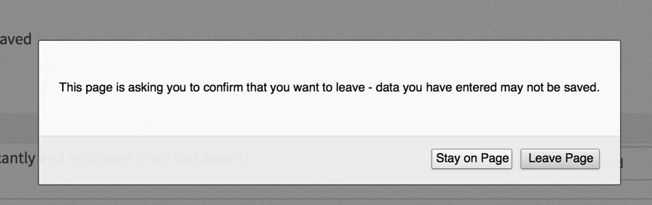

Edit and Save a greensheet
- Actor makes changes and requests to Save a greensheet
- The system performs validations. Refer to sec. BUSINESS RULES and Corresponding Errors => Validation rules => Validations on Save
- When all validations pass, the system will:
  - Save the answers/comments/attachments
  - Set the status to Saved
  - Record last updated date/time and Last Changed By (this field is displayed on the screen)
  - When user saves the “reconciled” GS (opened with the new template version), system deletes all answers associated with the “previous” template
  - If user selected and moved the attachment from the “bag” of unmatched attachments, selected attachments should be removed from the “bag” on save.
  - If the “parent” question’s answer has been changed, all answers/comments/attachments to sub-question(s), related to the prior answer, should be deleted. See the rule and example in sec. BUSINESS RULES and Corresponding Errors => Display rules => Expand/Collapse questions
- Use-case ends.

Reset a greensheet
- Actor requests to reset a greensheet
- The system provides a warning message: “Are you sure you want to reset the greensheet? All answers, comments and attachments will be deleted and the Greensheet status will be reset to “NOT STARTED”. Click OK to confirm the reset.”
Choices are “Cancel” (default) and “OK”.
- Actor provides a response
  - If Actor requests to Cancel, the system closes the pop up; no changes on the screen
  - If Actor clicks OK, the system will:
    - Delete all existing answers/comments/attachments
    - Change the greensheet status to NOT STARTED. NOTE: effectively, we are deleting the whole greensheet, so “last changed by”/”last changed date” will be blank)
    - Save the changes.
- Use-case ends

Submit a greensheet
- Actor makes or doesn’t make changes and requests to Submit a greensheet
- The system performs the same validations as on Save and additional validations on Submit. Refer to sec. BUSINESS RULES and Corresponding Errors => Validation rules => Validations on Save/ Validations on Submit
- When all validations pass, the system will:
  - Save the answers/comments/attachments
  - If the “parent” question’s answer has been changed, all answers/comments/attachments to sub-question(s), related to the prior answer, should be deleted. See the rule and example in sec. BUSINESS RULES and Corresponding Errors => Display rules => Expand/Collapse questions
  - Set the status to Submitted;
  - Records and Displays in the page header:
    - Last Changed By
    - Submitted By (before submission this field is not displayed)
    - Submitted On (before submission this field is not displayed)
  - Display the success message “Successfully Submitted! The greensheet has been successfully submitted and is now locked. No additional edits can be made.”
  - Greensheet is status Submitted is not editable, therefore the system hides Save/Submit/Reset Greensheet buttons
  - When user submits the “reconciled” GS (opened with the new template version), system deletes all answers associated with the “previous” template
  - Delete a ‘bag’ of unmatched attachments (if any)
- Use-case ends.

Manage attachment(s) for a selected question
- Actor requests to manage attachments for a specific question by clicking attachment icon for this question
- The system opens a “New Attachment” pop up, where:
- “Upload file” section => Ability to upload a file is provided as follow:
  - Actor locates the file on his/her local machine and requests to add it to the question (by clicking Choose File button).
  - The system performs validations. See sec. BUSINESS RULES and Corresponding Errors => B-001, B-002, B-003
  - If all validations pass, the system displays selected attachment in “Attachment(s) File List” section. Proceed to step “Actor requests to Save or Cancel the changes”
- “Attachment(s) File List” section => Displays attachment(s) that were already saved for this question (if any). The system provides ability to view and/or delete these attachment(s).
- If Actor requests to delete attachment that was already saved for this question, the system displays a warning: “Are you sure you want to delete attachment?”. Options are OK and Cancel. If Actor clicks OK, attachment is no longer displayed in the attachment file list.
Proceed to step “Actor requests to Save or Cancel the changes”

- Ability to Save or Cancel the changes is provided.
- Actor requests to Save or Cancel the changes
    - If Actor requests to Cancel the changes or close the attachment pop up, the system will close the pop up and no changes are saved.
    - If Actor requests to Save the changes, the system will:
      - Save the changes to the attachment list for this question
      - Close attachment window
      - Depending on existence of attachment(s) display the correct attachment icon (see sec. User Interface => Questionnaire)

- Use-case ends.

Note:

Exception Flows
Please refer to sec. Business Rules and Corresponding Errors => Validation rules

POST-CONDITIONS

Post-conditions upon Success

Greensheet is displayed

Greensheet is Edited and Saved

Greensheet is reset

Greensheet is submitted

Post-Conditions upon Failure

System error is displayed for unhandled errors

Error message(s) are displayed for handled validation errors

EXTENSION POINTS

Create PDF
https://ncisvn.nci.nih.gov/svn/iscs/greensheets/Requirements/Use-cases/Print%20a%20greensheet%20use-case.doc

BUSINESS RULES and Corresponding Errors

Display rules
Name | Rule
Read-only greensheets when GPMATS action is in Closed status | If GPMATS action is in Closed status, greentheet should be read-only, regardless of gs status
When Save button is functional? | If GPMATS action is NOT in Closed status, Save button is functional only if:  - The greensheet is a program greensheet, the user is a PD who is the official NCI PD assigned to this grant (of whom there is always only one for each grant), and the greensheet's status is NOT_STARTED or SAVED or UNSUBMITTED and grant CA is in the list of PD assigned and/or monitored cancer activities (displayed in the dropdown)  OR  - The greensheet is a program greensheet, the user is a different PD (not assigned to this grant), but the user monitors Cancer Activity (CA) that matches the grant's CA and the greensheet's status is NOT_STARTED or SAVED or UNSUBMITTED  OR  - The greensheet is a program greensheet for a grant that is a Diversity Supplement, the user Diversity Supplement PD, and the greensheet's status is NOT_STARTED or SAVED or UNSUBMITTED  OR  - The greensheet is a program greensheet, the user is a Program Staff (PS) assigned as a "Cancer Activity Monitor" for a CA that matches this grant's Cancer Activity, and the greensheet's status is NOT_STARTED or SAVED or UNSUBMITTED  OR  - The greensheet is a Specialist or Revision type of greensheet and the user is a Specialist, and the greensheet's status is NOT_STARTED or SAVED or UNSUBMITTED  In all other situations, Save button is NOT functional.
When Submit button is functional? | If GPMATS action is NOT in Closed status, Submit button is functional only if:  - The greensheet is a program greensheet, the user is a PD who is the official NCI PD assigned to this grant (of whom there is always only one for each grant), an AWARD action has been added "in GPMATS" and GPMATS action is NOT in Cancelled status, and the greensheet's status is NOT_STARTED or SAVED or UNSUBMITTED and grant CA is in the list of PD assigned and/or monitored cancer activities (displayed in the dropdown)  OR  - The greensheet is a program greensheet, the user is a different PD than this grant's PD, but the user monitors a Cancer Activity (CA) that matches the grant's Cancer Activity, an AWARD action has been added "in GPMATS" and GPMATS action is NOT in Cancelled status, and the greensheet's status is NOT_STARTED or SAVED or UNSUBMITTED  OR  - The greensheet is a program greensheet for a grant that is a Diversity Supplement, the user is Diversity Supplement PD, an AWARD action has been added "in GPMATS" and GPMATS action is NOT in Cancelled status, and the greensheet's status is NOT_STARTED or SAVED or UNSUBMITTED  OR  - The greensheet is a specialist greensheet, the user is a Grants Management Specialist, an AWARD action has been added "in GPMATS" and GPMATS action is NOT in Cancelled status, and the greensheet's status is NOT_STARTED or SAVED or UNSUBMITTED.  OR  - The greensheet is a revision greensheet, the user is a Grants Management Specialist, an REVISION action has been added "in GPMATS", and the greensheet's status is NOT_STARTED or SAVED or UNSUBMITTED. Note: when Revision action is in Cancelled status, Revision greensheet must be deleted.  In all other cases Submit button is NOT functional
When Submit button is displayed as grayed out on Program GS? | Grayed out Submit button can be displayed on Program greensheet for the following reasons:  - AWARD action is not created in GPMATS  - GPMATS AWARD action is in Cancelled status  If submit button is grayed out, the tool tip should be provided when an Actor hovers over the button.  Tool tip text: “You cannot submit because <insert appropriate reason>”
When Reset Greensheet button is functional? (Same rules as for Save) | If GPMATS action is NOT in Closed status, Reset Greensheet button is functional only if:  - The greensheet is a program greensheet, the user is a PD who is the official NCI PD assigned to this grant (of whom there is always only one for each grant), and the greensheet's status is NOT_STARTED or SAVED or UNSUBMITTED and grant CA is in the list of PD assigned and/or monitored cancer activities (displayed in the dropdown)  OR  - The greensheet is a program greensheet, the user is a different PD (not assigned to this grant), but the user monitors Cancer Activity (CA) that matches the grant's CA and the greensheet's status is NOT_STARTED or SAVED or UNSUBMITTED  OR  - The greensheet is a program greensheet for a grant that is a Diversity Supplement, the user Diversity Supplement PD, and the greensheet's status is NOT_STARTED or SAVED or UNSUBMITTED  OR  - The greensheet is a program greensheet, the user is a Program Staff (PS) assigned as a "Cancer Activity Monitor" for a CA that matches this grant's Cancer Activity, and the greensheet's status is NOT_STARTED or SAVED or UNSUBMITTED  OR  - The greensheet is a Specialist or Revision type of greensheet and the user is a Specialist, and the greensheet's status is NOT_STARTED or SAVED or UNSUBMITTED  In all other situations, the Reset Greensheet button is not functional.
Expand/Collapse questions | Levels:  Each level of sub-questions should have its own expand/collapse functionality.  When we talk about expanding/collapsing, it is always only one level down, e.g. from 7 to 7.1. If sub-question 7.1 has next level sub-question(s) 7.1.1 and 7.1.2, they are NOT displayed when question #7 is expanded.  Rules:  - If a question does NOT have sub-question(s) => do NOT display sub-question icon  - f a question HAS sub-question(s) => expand/collapse icons are provided /  - When Actor opens a gs => all triangles are pointing to the right , at the same time all answered questions are expanded. All unanswered questions are hidden. Actor can collapse answered sub-question  - If parent question is not answered, then all sub-questions (and their comments and attachments functionality) for all answer options will be displayed in read-only mode (user cannot select an answer for the sub-questions).  - If any answer option is selected to the parent question, the system displays the next level sub-questions that are related to the selected answer option. This sub-questions are in editable mode (user can select answers for them and edit comments/attachments for them)  - If Actor explicitly requested to display/hide next level sub-questions by clicking /, then the system will display/hide the next level of sub-question(s) for all top-level answer options. The system should NOT provide ability to edit sub-question(s) and their comments/attachments that belongs to the not-selected answer option of the parent.  - If the “parent” question’s answer has been changed, all sub-questions that were opened should be hidden and their values (including comments and attachments) should be reset; the triangle will be pointing down although only answer related questions will be shown.  To see answer non-related questions user should click on triangle twice (“close” -> “reopen”).  E.g.  Step 1:  ---------------------------------------------------------------------------------------------------  7. Parent Question text  7.1 Sub-question 1 text  7.2 Sub-question 2 text  -------------------------------------------------------------------------------------------------------------  Step 2: If user changes answer for #7 to No (that doesn’t have sub-questions), and the result on the screen will be:  ---------------------------------------------------------------------------------------------  7. Parent Question text  -----------------------------------------------------------------------------------------------  Step 3: The system will delete the answer/comments/attachments for 7.1  Step 4: If user once again changes the answer to Yes, s/he will see  ----------------------------------------------------------------------------------------------------  7. Parent Question text  7.1 Sub-question 1 text  7.2 Sub-question 2 text  -------------------------------------------------------------------------------------------------------
How to format questions and sub-question? | If definition of the question includes sub-questions:  - Each next level of sub-questions is undented to the right  - System will number all questions and sub-questions, including the numbers of all higher-level questions (for example, "1.4.2.1")  - System will display the text of instructions directly below the text of the question itself;  - Formatting of the instructions comes from Form Builder formatting  - When user clicks active URL in the questions instructions, the system should open the link in a separate browser window.
How to display answers? | - System will check in the database whether some user already saved answers to some or all questions of this greensheet form for this grant previously. If that is the case, system will pre-populate the UI controls for the answer with values already saved in the database.  - If the user's role does not allow him or her to provide responses, or the status of the greensheet is "SUBMITTED" or "FROZEN" or GPMATS AWARD action is in Cancelled status, system will show those controls as "disabled".

Validation rules
Name | Rule | Error
Attachment validation rules
B-001 | The name of the file user tries to attach to the same question must be unique. | A file with the specified name already exists. Please rename the file before attempting to attach
B-002 | If user tries to attach to a particular question a file whose name matches name(s) of files attached to a different question on the same greensheet form, or to any question(s) on a form for any different grant, system will support the ability to accomplish that | n/a
B-003 | For an attachment, the size must be at most 10MB  Max size is set in greensheetsconfig.properties in the property file.attachment.size.limit  NOTE: The value in <> will change depending on the limit that is set in greensheetsconfig.properties | The File you are attaching is too large. The file must be less than <10>mb.
B-010 | The name of the file you are attaching exceeds 100 characters | The name of the file you are attaching exceeds 100 characters. The selected file name size is <insert number> characters. Rename the file and attach again.
Validations on Save
If at least one validation rule did not pass:
- Error message is displayed at the top of the screen “Error! The form cannot be submitted until the errors indicated on the form are corrected.”
- Each question/answer with error is highlighted and individual error is displayed
B-004 | Comment field length should not exceed 4000 characters in length | Comment couldn’t exceed 4,000 characters
B-005 | Multi-line text field in answer should not exceed 2000 characters in length | Multi-line answer couldn’t exceed 2,000 characters
B-006 | Text string field in answer should not exceed 250 characters in length | n/a (NOTE: after that the message will be cut, existing implementation)
B-007 | Number value in answer should be in fact numeric. The only non-numeric characters allowed are "+", "-", and "." "+" and "-" can only occur at the beginning of the entered value. | ‘Number’ answer type can only contain numbers and the symbols {‘-‘, ‘+’, ‘.’}.  Note: Either ‘-‘ or ‘+’ can appear only at the beginning of the value.
B-008 | Date format should be mm/dd/yyyy | Date format should be mm/dd/yyyy
Validations on Submit
On Submit all validations on Save should be repeated and additional validations should be performed
NOTE: Individual validations come from Form Builder: GSFB passes validation rules within XML file. GS processes XML and insert client side validation into the HTML Blob stored in the database
B-009 | Every parent question displayed on a greensheet must have an answer on Submission.  Parent question might have a sub-question. Sub-question(s) are displayed or not based on the answer to a parent.  If sub-question(s) are displayed, the answer to each displayed sub-question is required on Submission.  If sub-question(s) are NOT displayed, the answer is NOT required  Special case: A question without any answer options can be promoted from Form Builder. In such case, validations on Submit should skip such question. See example below (last question).  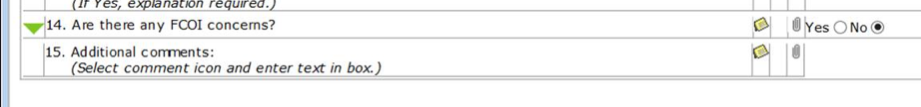 | If at least one validation rule did not pass:  - Error message is displayed at the top of the screen “Error! The form cannot be submitted until the errors indicated on the form are corrected.”  - Each question/answer with error is highlighted and individual error is displayed

Information messages table
Name | Message text
I-001 | “This Greensheet template has been updated and the questions may have changed.  Please check the answers/comments/attachments for correctness. The system has performed a match where it was possible.  To re-attach unmatched files click the Attachment icon and make a manual selection.”

USER INTERFACE

UI Mockups

Greensheet questionnaire mockup
https://ncisvn.nci.nih.gov/svn/iscs/greensheets/Requirements/Presentations/JuneDemo/greensheet.htm
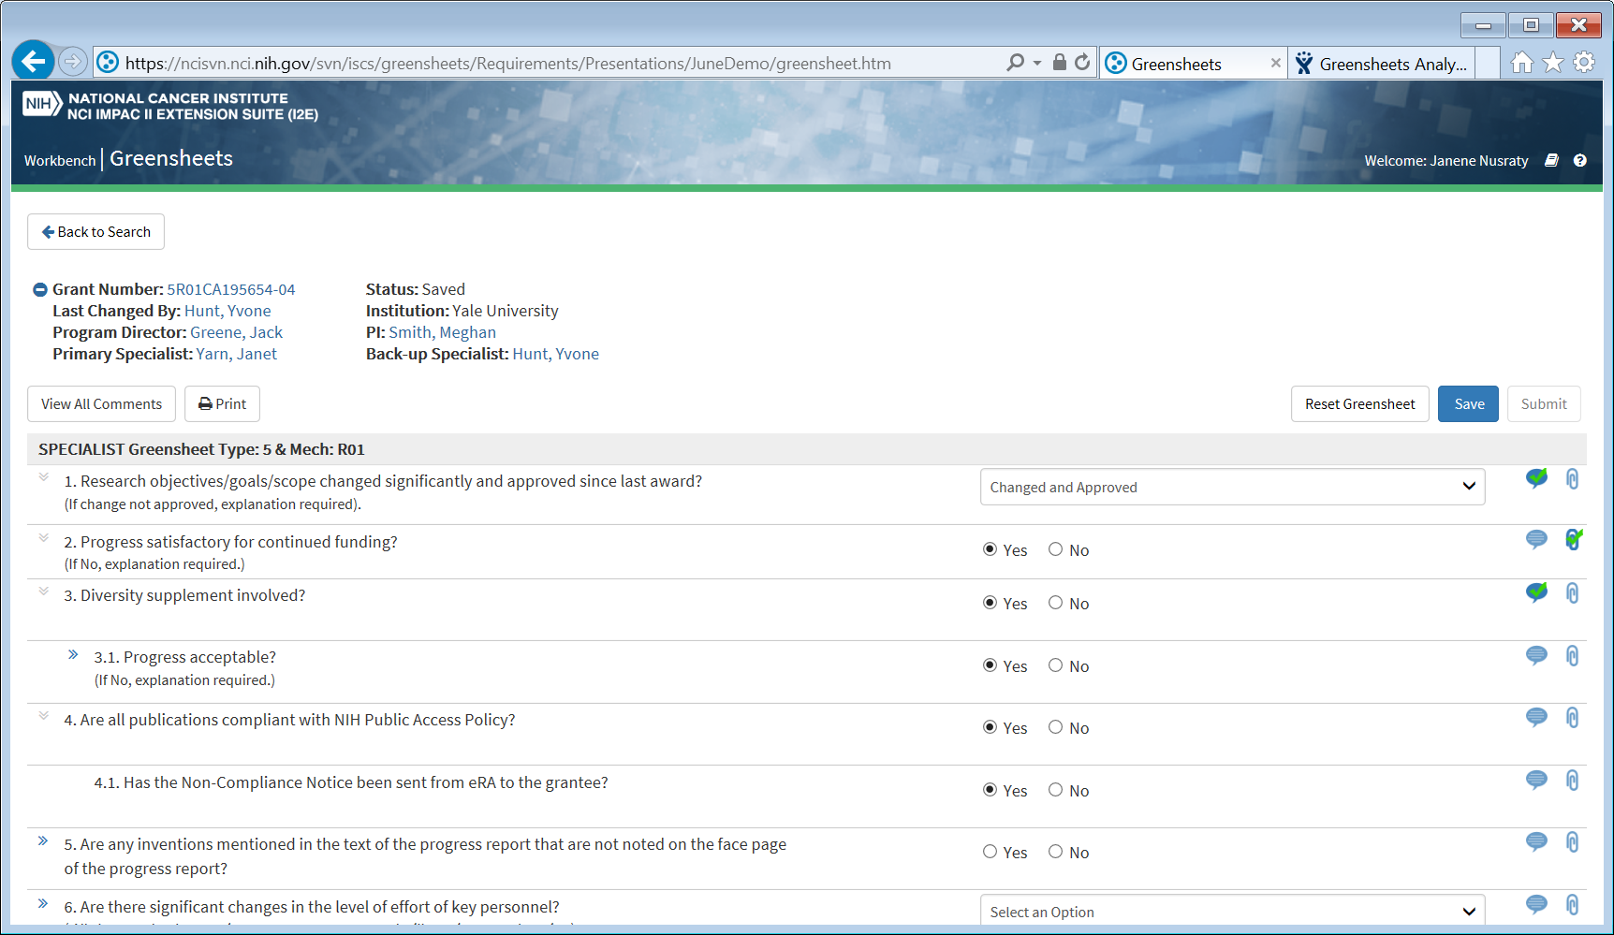

Greenseet after a new template has been promoted
https://ncisvn.nci.nih.gov/svn/iscs/greensheets/Requirements/Presentations/JuneDemo/greensheet-nonWBUpdated.htm
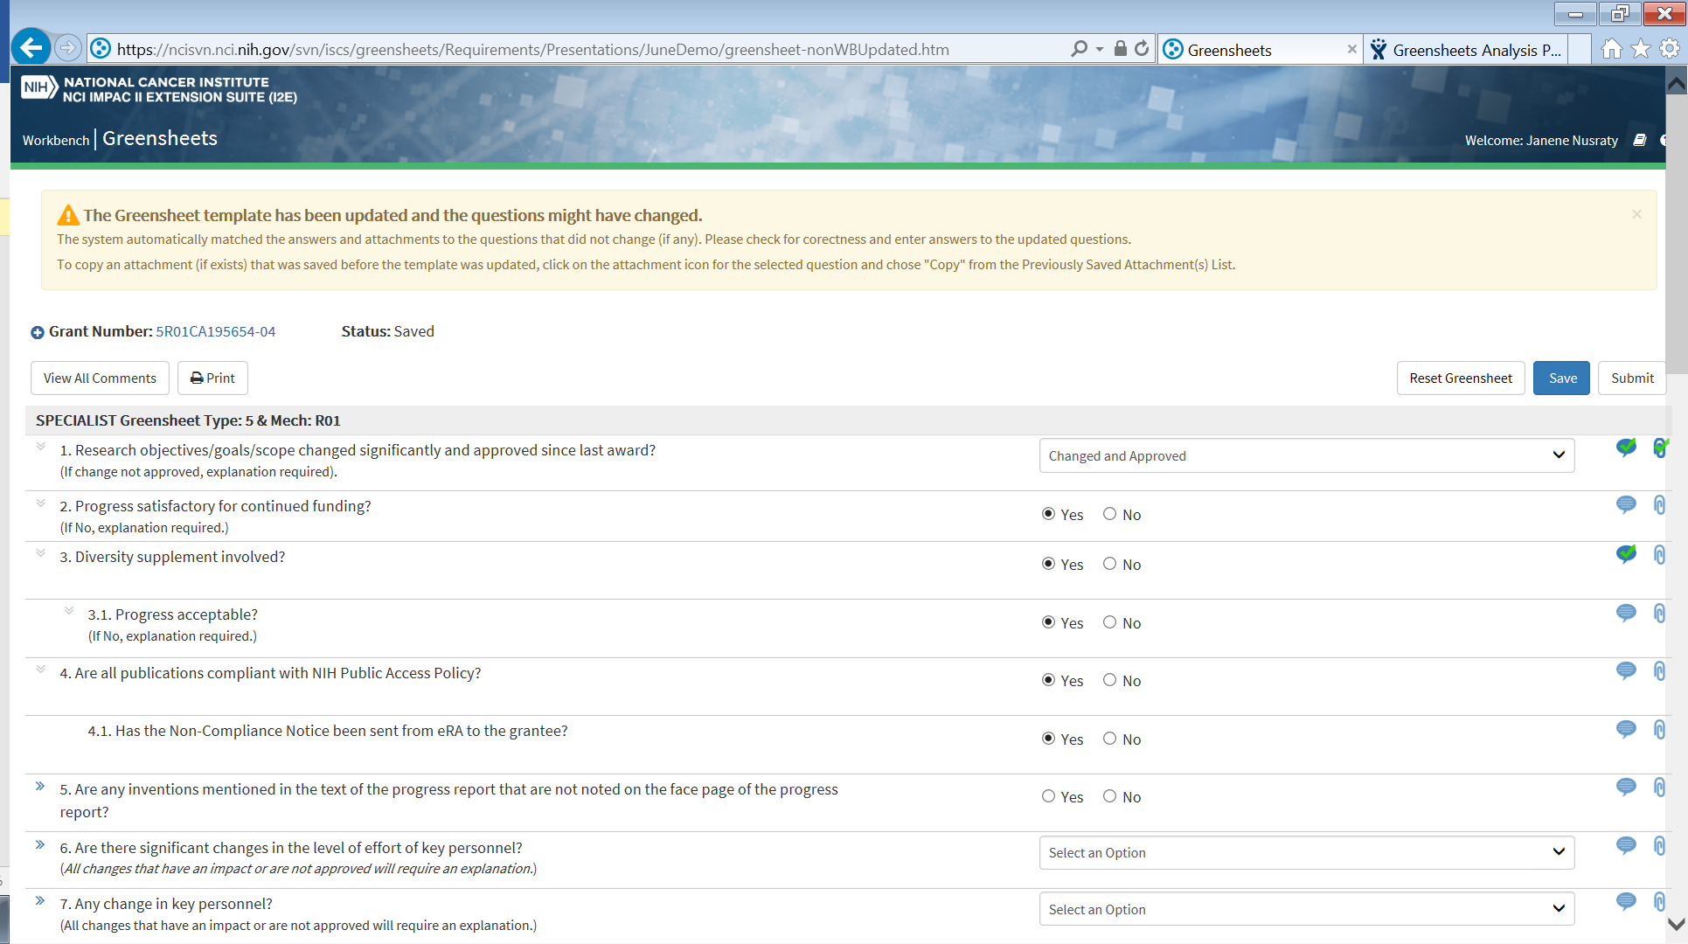

Greenseet Submitted or Frozen
https://ncisvn.nci.nih.gov/svn/iscs/greensheets/Requirements/Presentations/JuneDemo/nonWBgreensheet-submitted.htm
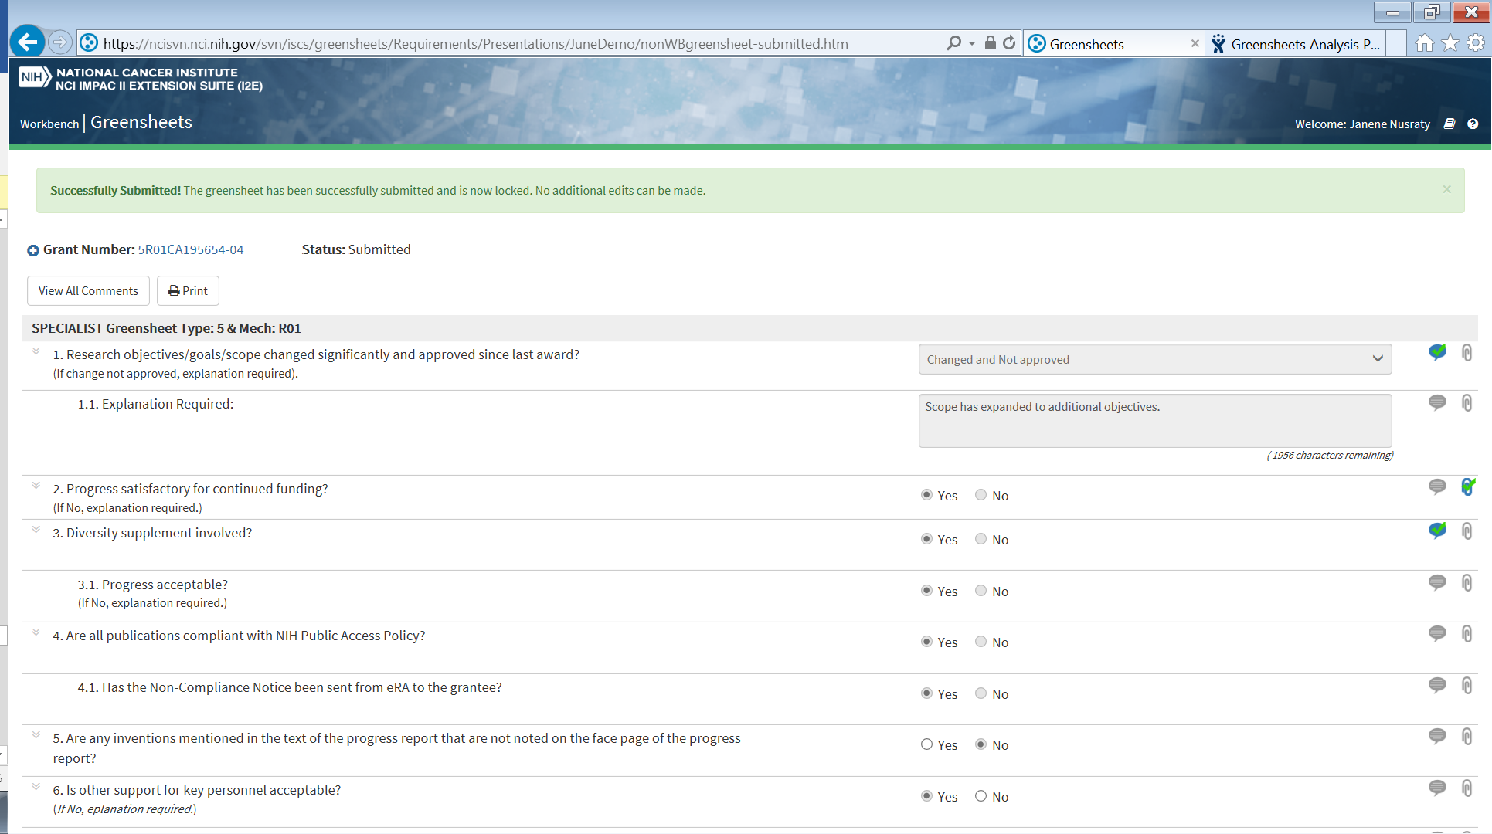

Attachment(s) pop up
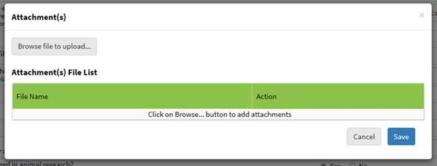
Note: Add the text next to the “Browse…” button
“File name should not exceed 100 characters.
File size should not exceed 10 MB. “

UI Specifications

Grant Header
- Ability to collapse/expand is provided
- Collapsed by default (to be confirmed during UAT, OGA will have an internal discussion and let CBIIT know what other information (if any) should be displayed in the header)
Element Name | Description | Element Type | Display rules and Comments
Grant Number | Displays grant number. | Hyperlink | Hyperlinked to Grant Details page for this grant in Your Grants
Last Changed By | Last, First Name of the person who last updated the greensheet | Hyperlink | - Hyperlinked to user’s email client (Outlook). When clicked, TO: will be pre-populated with email of this person  - Should NOT be displayed in the header when gs is in NOT STARTED status
Submitted By | Last, First Name of the person who submitted the greensheet | Hyperlink | - Hyperlinked to user’s email client (Outlook). When clicked, TO: will be pre-populated with email of this person  - Should be displayed in the header only when gs in Submitted ot Frozen status  - If gs is unlocked (status is Unsubmitted), ‘Submitter’ and ‘Submitted Date’ should disappear.
Submitted On | Date when the greensheet has been submitted | Read-only | - Format MM/DD/YYYY  - Should be displayed in the header only when gs in Submitted ot Frozen status  - If gs is unlocked (status is Unsubmitted), ‘Submitter’ and ‘Submitted Date’ should disappear.
Program Director | Program Director Last, First Name | Hyperlink | Hyperlinked to user’s email client (Outlook). When clicked, TO: will be pre-populated with email of this person
Primary Specialist | Primary Specialist Last, First Name | Hyperlink | Hyperlinked to user’s email client (Outlook). When clicked, TO: will be pre-populated with email of this person
Status | Greensheet status | Read-only
Institution | Institution | Read-only
PI | PI Last, First Name | Hyperlink | Hyperlinked to user’s email client (Outlook). When clicked, TO: will be pre-populated with email of this person
Back-up Specialist | Back-up Specialist Last, First Name | Hyperlink | Hyperlinked to user’s email client (Outlook). When clicked, TO: will be pre-populated with email of this person
POC | Allows to enter Point of Contact (POC) | Enterable Field or read-only | Displayed only on Program Greensheet  - Enterable field when Actor is is allowed to edit this Program gs and gs is in status NOT Started or Saved or Un-submitted  - Read-only in all other cases

Links and Buttons
NOTE: all buttons should be displayed above and below a questionnaire
Element Name | Description | Element Type | Comments
Back to Search | Takes Actor to the first page of the grants hitlist | Navigation link | Displayed only if Actor navigated to this questionnaire from a Search/Hitlist page in Greensheets system
View All Comments/Hide All Comments | Allows to view/hide all entered comments; if comments were not entered, they stay collapsed. | Button | Left justified, always displayed
Print | See this document, Extension points => Create PDF | Button | Left justified, always displayed
Save | See this document, Alternative flow => Save a greensheet | Button | - See this document, sec. Business Rules => When Save button is functional  - Right justified
Submit | See this document, Alternative flow => Submit a greensheet | Button | - See this document, sec. Business Rules => When Submit button is functional  - See this document, sec. Business Rules => When Submit button is displayed as grayed out on Program GS  - Right justified
Reset Greensheet | See this document, Alternative flow => Reset a greensheet | Button | - See this document, sec. Business Rules => When Reset Greensheet button is functional (same rules as for Save)  - Right justified

Questionnaire
Element Name | Description | Element Type | Rules and Comments
Questionnaire Header | Displays the type of a greensheet and related type/mech  - Greensheet class (possible values: "PROGRAM" or "SPECIALIST" or “REVISION”)  - Grant's application type (labeled "Type:")  - Grant's funding mechanism (labeled "Mech:") | Read-only
Questionnaire elements
Sub-question indicator column | Icon that indicates the existence of sub-question(s). Displayed conditionally. | Icon | See this document, sec. Business Rules => Expand/Collapse questions
Text of the question | Displays the text of a question and instructions (if any); presided by question number. | Test of the question => Read-only  Instructions might have an active hyperlink and/or be read-only | See this document, sec. Business Rules => Display Rules => How to display questions and sub-question
Answers | Allows a user to provide answers to a question. | - String  - Text  - Number  - Date  - Radio button list  - Drop-down  - Checkboxes list | - See sec. BUSINESS RULES and Corresponding Errors => Validation Rules  - Next to Date - display a "calendar" image. If user selects that image, system will present a "calendar flyout", in which user will be able to select a date using the mouse and not having to enter it from keyboard. (Entry of date value from keyboard directly into a text-entry box will also be possible.)  - For answer type Radio Button (or sometimes checkbox) can have only one option of the answer (e.g. Yes); this situation is allowed.
Comments | Allows entering a comment for a question;  Enterable field is collapsed by default. User can expand it by clicking a comment icon  If a comment is NOT entered, the icon is appearing as NOT checked  If a comment IS entered, the icon is appearing as checked | Icon  And enterable field | Tool tip should be provided for the icon “Add Comments”  Comment field must be 4,000 characters (NOTE: after that the message will be cut)  Character counts should be provided for this enterable field
Attachment | If there are no attachments for this question, the icon appears as NOT checked ;  if there is at least one attachment for this question, the icon appears as checked  | Icon | Tool tip should be provided for the icon “Add Attachments”  See alternative flow “Manage attachment(s) for a selected question”

REPORTING REQUIREMENTS
Please refer to GreenSheets Re-design Project Scope, sec. Reporting => Ad-hoc report at OGA request – change for re-design
https://ncisvn.nci.nih.gov/svn/iscs/greensheets/Requirements/Specs/GreenSheets%20Redesign%20Project%20Scope.docx

Additional requirements

Tool tips
Below is a list of all possible tooltips when user opens a greensheet form and “Save” or “Submit buttons are disable.
Users will see these tooltips when they hover the mouse over the buttons.

Case 1 – Form is read-only, “Save”, “Reset” and “Submit” buttons are disabled.
The tooltip will show one of these messages (in an order of appearance):
- "Specialist Greensheet is Read Only if you don't have Specialist role"
- "Revision Greensheet is Read Only if you don't have Specialist role"
- "Program Greensheet is Read Only if you don't have Program Director or Program Staff role"
- "Program Greensheet is Read Only if you are assigned PD but you don't have <CA Code> cancer activity assigned/monitored"
- "Program Greensheet is Read Only if you are not assigned PD and you don't monitor <CA Code> cancer activity"
- "Program Greensheet is Read Only if you have Program Staff role and you are not assigned to monitor <CA Code> cancer activity"
- “Greensheet for OGA Closed Action is read-only”
- "Greensheet with SUBMITTED status is Read Only"
- "Greensheet is Read Only if you don't have Specialist, Program Director, or Program Staff role"

Case 2 – Form is editable, but “Submit” button is disabled
- "You cannot submit Greensheet because AWARD action is not created by OGA or AWARD action has been cancelled"

Greensheet is NOT available
The system does not provide access to a greensheet in several cases (Search screen displays ‘I’ icon instead of ‘G” icon and other systems (GPMATS/YourGrants/Notifications) are hiding ‘G’ icon. If user is trying to access to greensheet screen via URL, instead of the form, the screen should display the same messages as tool tips for ‘I’ icon. Please refer to
https://ncisvn.nci.nih.gov/svn/iscs/greensheets/Requirements/Use-cases/Search%20and%20View%20greensheets.doc
sec. BUSINESS RULES => When greensheet exists (when to display “G” icon for greensheet)?

